Graphics Design

I

Class vii

Lab 20

**Lab Objectives:**

* Online Graphic Design Tool
* Creating a Simple Project

Tools for Graphics Design

There are two types of tools (Software) for Graphics Design.

1. Online Tools
2. Offline Tools

The most popular offline software for Graphics Design are Adobe Photoshop and Adobe Illustrator. They need to be purchased from its owner “Adobe Systems” to use. But in this lecture we are going to learn Online Tools. It’s free for primary use, super easy and its name is *Canva.*

Introduction to Canva

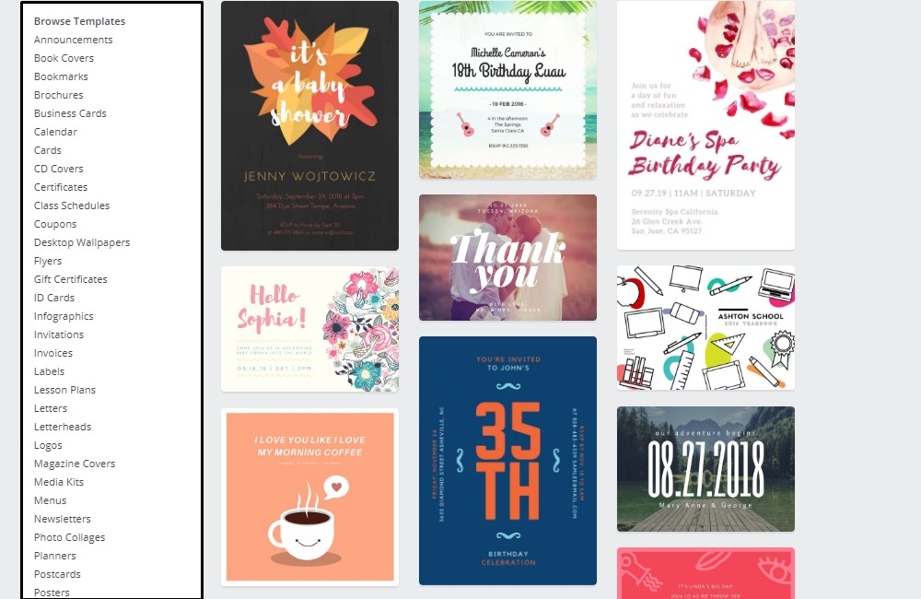There are lots of templates to fulfill your specific design. You just have to select that which type of design you need. It may be a Facebook cover photo, poster, presentation, flyer, business card, invitation letter etc.

Starting Design on Canva

You only need internet connection to start design. Let’s start

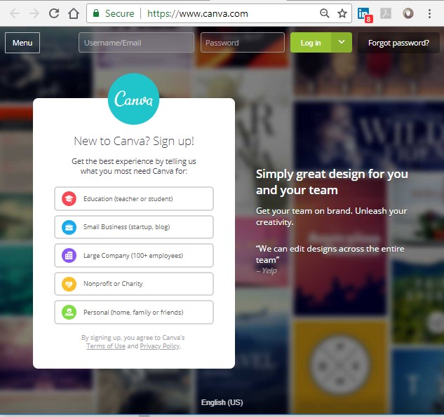Go to [www.canva.com](http://www.canva.com)

Click on Education *(teacher or student)*

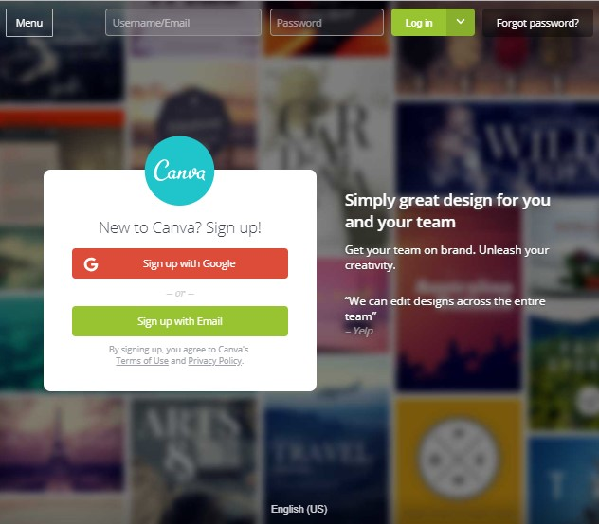now signup with Google or Email to lunch

After signing in click on *I’m in. Show me Canva 2.0*

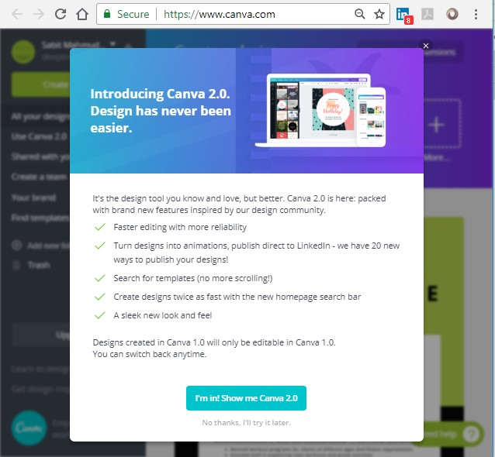

We are going to design a poster. So type poster on search bar and press Enter button from your key board. You’ll find lots of poster templates to modify.

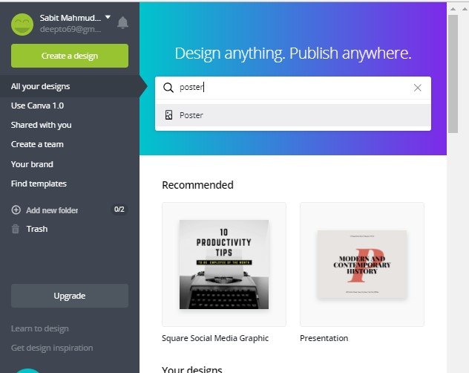

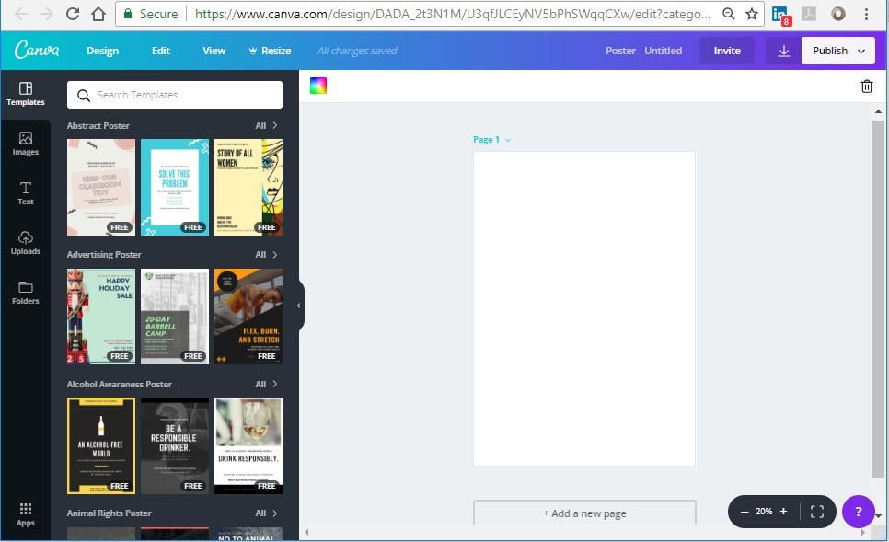This is the canvas page for your design. From the left column you’ll see lots of templates to design your poster. Choose a template and change the text as required. You can add custom images to your design by clicking on images from the very left column.

Now choose a template to edit.

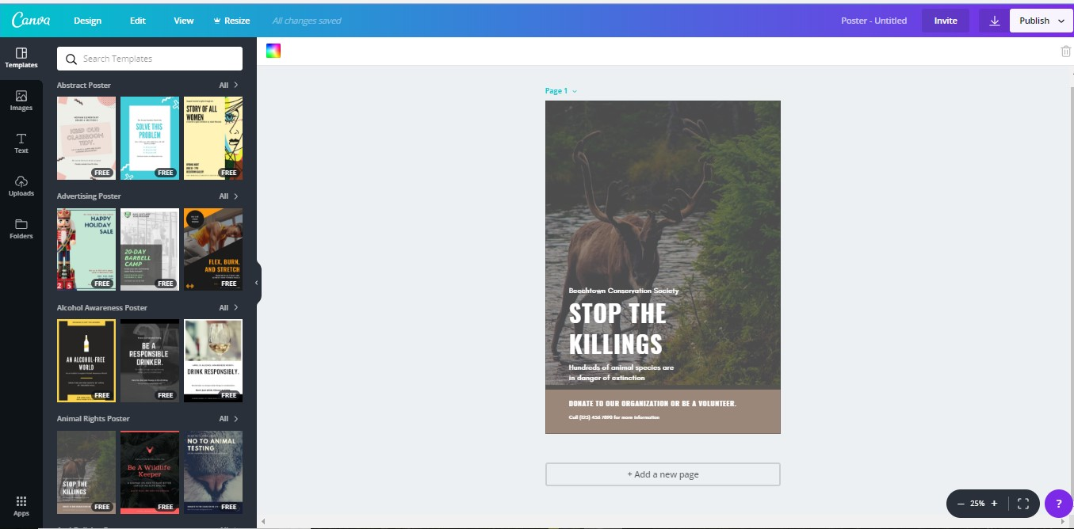We have chosen our template. Now remove all text and write something new on it.

We removed the text and replace “We Love Animals” and changed it color to white by clicking on “A” from the top row.

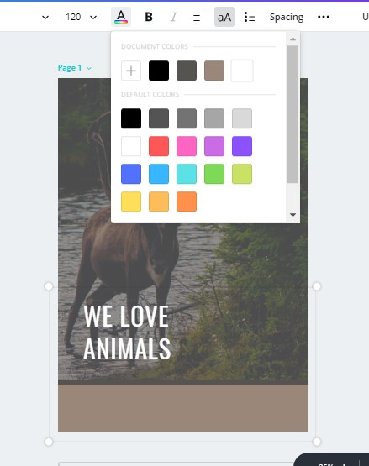

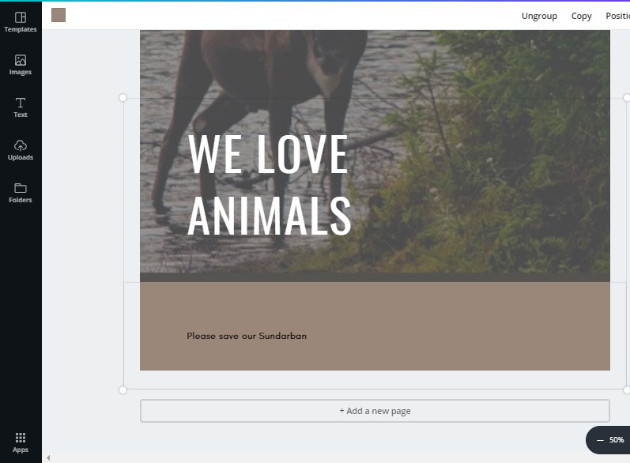We also write “please save our Sundarbans” on footer

You can change the font size of text. Now we’ll change the font size of footer

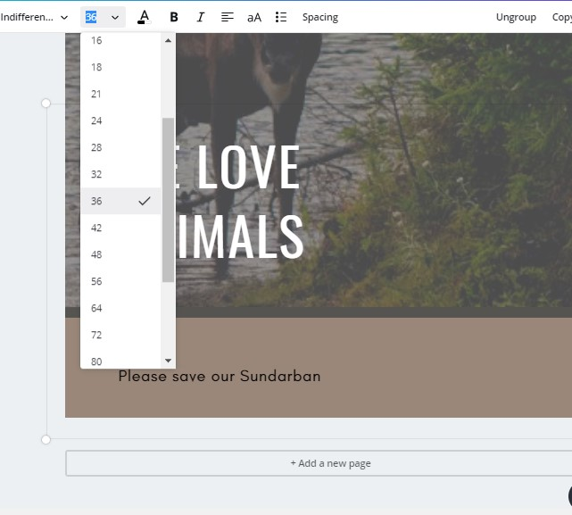

After doing this it’s time to save the poster.

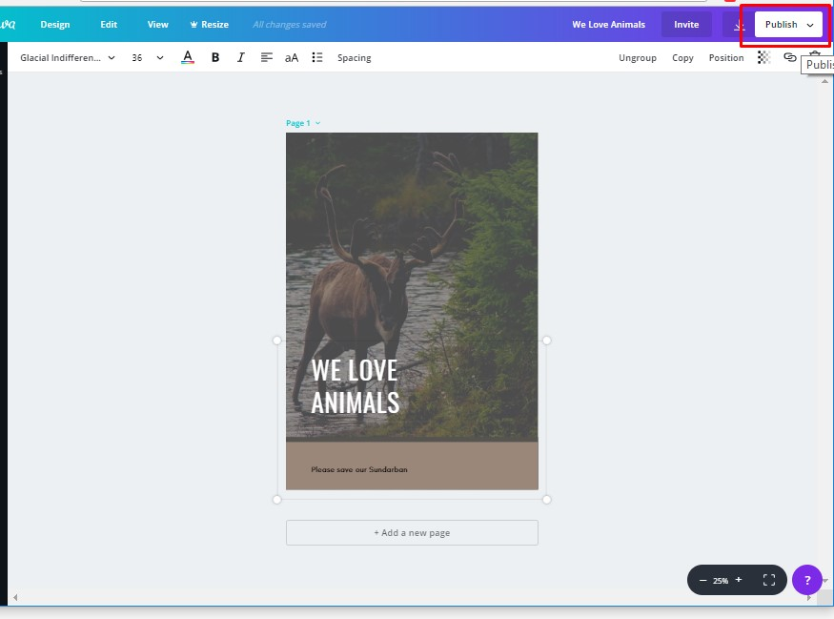Click on publish then click “jpg”

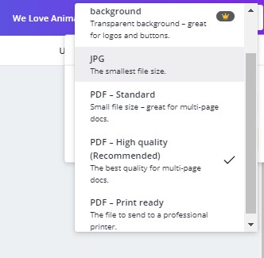

Click on Download

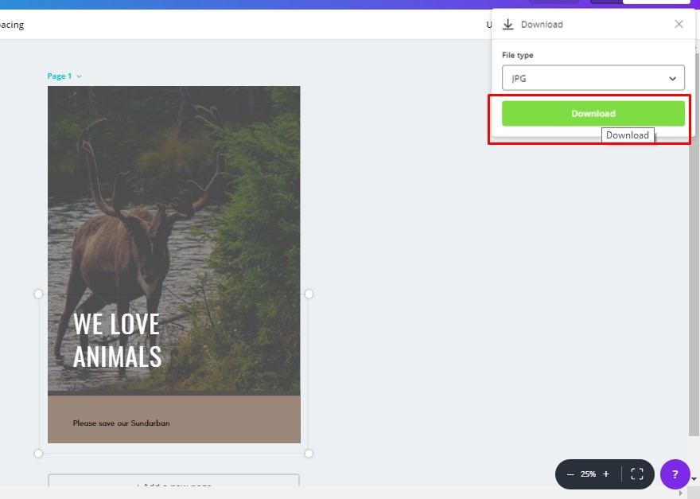

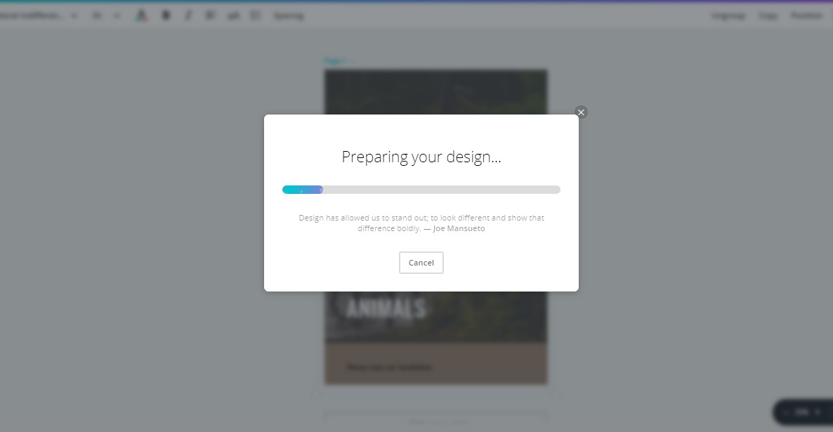 Downloading

Give a file name and click on save



It’s saved on your computer. So we have completed our first graphic design project. Here is our first “Poster”.

